San Jose State University

EE250 (Section 2) Fall 2019 Prof. Kamali

Problem Set #5

- Problem 5.12
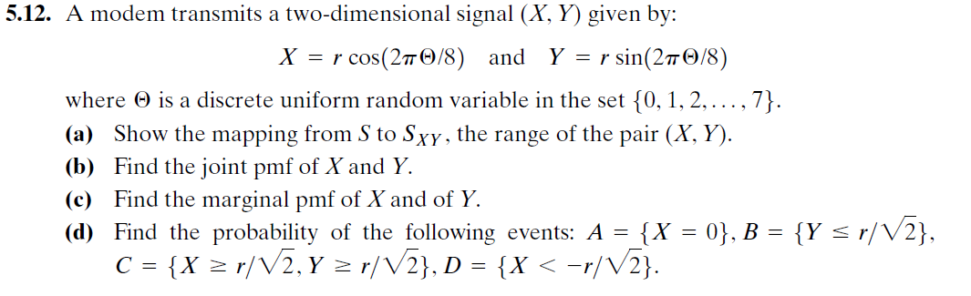

- Problem 5.28
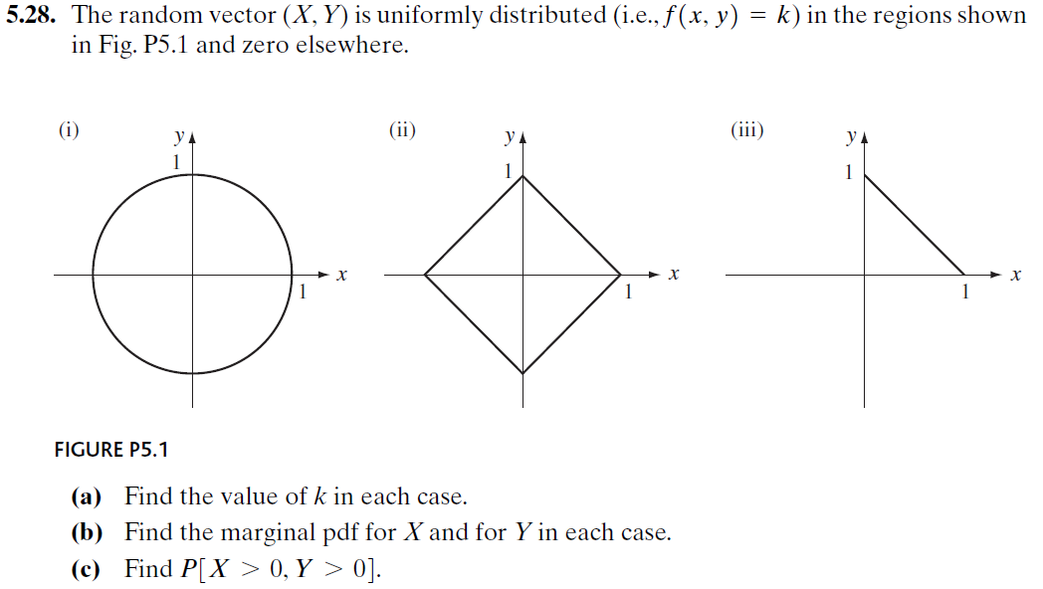

- Problem 5.51

- Problem 5.71
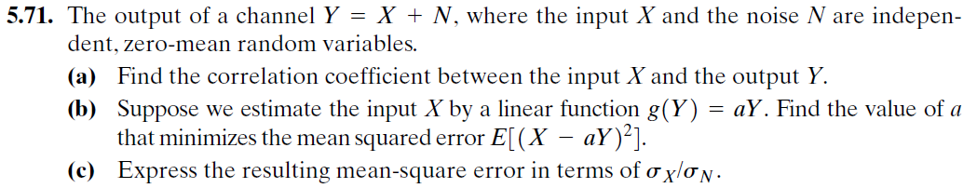

- [Midterm, Summer 2008] Two discrete random variable 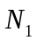and 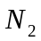have the following joint pmf.

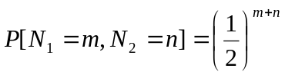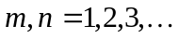

Find the probability 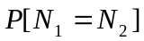.

- [Final exam, Spring 2014] The joint pdf of random variables 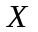 and 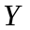is given as follows.

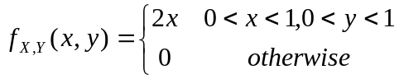
- Find 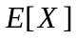.
- Find the marginal pdf 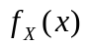 and 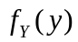.
- Are and independent?

- [Midterm, Spring 2015] The pdf of the random variable is given as follows.

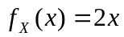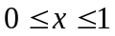

Find the correlation coefficient 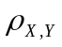between and 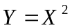.

- [Midterm, Fall 2015] The joint pmf of the discrete random pair 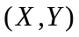 is given in the following table. Find 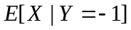.

 | 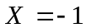 | 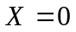 | 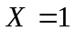
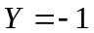 | 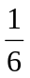 | 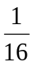
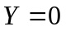
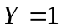

- [Midterm, Fall 2015] The joint pdf of the random pair is given as follows.

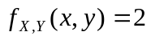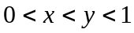

- Find the marginal pdf 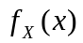 and 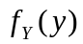.
- Find the covariance of and ().

- [Midterm, Spring 2009] Suppose is a zero mean Gaussian random variable and is independent of. Find the correlation coefficient 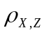 where 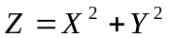.

- [Midterm, Fall 2017] The joint pdf of the random pair is given as follows.

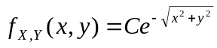 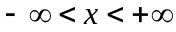, 

- Find .
- Find the probability

